Update Checker for California Anti-Displacement Policy Map
Chenghao Li and Karen Chapple
Urban Displacement Project, UC-Berkeley
February 23, 2026

The California Anti-Displacement Policy Map is based on regulations and programs in place in 2025. However, policies can change over time. Users of the Map should be sure to check for changes via both the website of the jurisdiction and the legal database where it posts its ordinances (whether Municode, American Legal Publishing, or General Code).

The Urban Displacement Project has built an Update Checker to enable users to check quickly whether an ordinance has changed. The Update Checker will only work for jurisdictions that have posted in the Municode database (about 2/3 of all jurisdictions in California). It uses the Python language. This document provides a tutorial on how to use the Checker.

The Update Checker begins with the full table of ordinances provided in .csv format at https://www.urbandisplacement.org/maps/california-anti-displacement-policy-map/. Update Checker works by iterating through the table and checking the Municode links to see whether or not there have been any new updates to the ordinance since the last date checked (in 2025). It does this by checking the page for every valid supplement from the current date to the date of last update to see if there has been any changes in any of the supplements, regardless of how small of a change it is. This means even small changes like an added space or a removed punctuation mark could trigger the program to say that the policy requires an update.

For example, if a change is detected in a document on 2/20/26 when the date last checked was 1/16/26, it will register as requiring an update, no matter how small the change may be. The user will need to compare versions manually (or with Compare Documents in Word) to determine what the change is.

The following tutorial explains how to run the Update Checker program.

Initial setup:
- Ensure you have the latest version of python and git installed
  - https://www.python.org/ https://git-scm.com/
- Clone the repository (if git cmd and command prompt dont work, try anaconda prompt)
git clone https://github.com/xa1on/CARB-GEN-AI.git
- CD into the repository
cd CARB-GEN-AI
- Install the requirements via pip or uv
pip install -r requirements.txt

Update checker setup:
- Ensure you have a copy of the ordinance table in the form of a csv with a “Date Checked” column.
  - This can be found at https://www.urbandisplacement.org/maps/california-anti-displacement-policy-map/.
Download the policy ordinance database

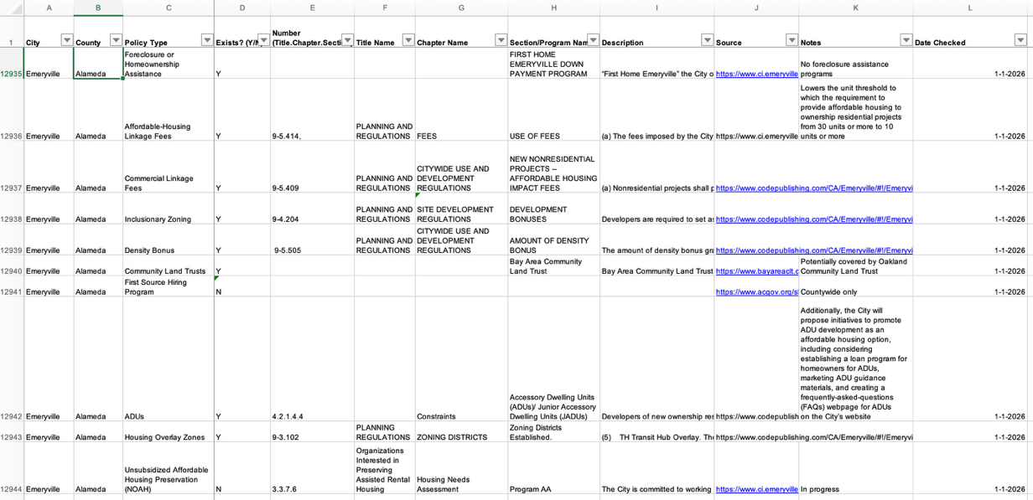

- In Jupyter notebook/Python, update the CSV_FILE variable within src/scrapers/check_updates.py to point towards the location of the CSV file
  - Example (Code inside of src/scrapers/check_updates.py):
CSV_FILE = "data/datasets/2025 ARB Policy Map Ordinance Table - Copy of Master (Auto-Updates).csv"

- Update the location where you want the log file to be saved
  - Example (src/scrapers/check_updates.py):
OUTPUT_FILE = "logs/updates.txt"

- Choose whether you want a verbose response via the VERBOSE variable
  - A value of “True” means that the program will log all the policies and cities it checks, however, a value of “False” will only output policies that require updates

Running Update Checker
- In order to decide what to run the checker for all the cities in the provided csv, or for only a specific city, set the RUN_ALL variable to the right true or false value.
- In order to start the program, run the following command from the project’s root directory:
python -m src.check_updates

- A text file containing the output will be placed in OUTPUT_FILE and will progressively update as cities are checked.

